350 series Hot plate and Stirrer
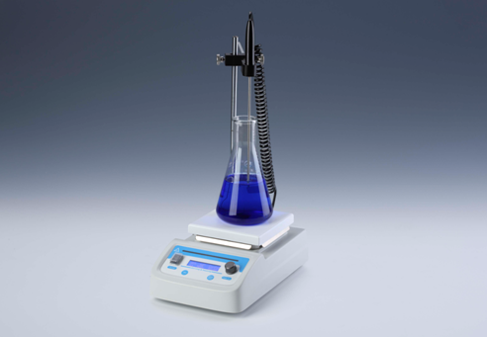
Description:
Hotplate, Magnetic Stirrer and Hotplate Stirrer feature an exceptionally durable, chemical resistant white ceramic work surface. The space-efficient design makes them ideal for use on crowded benchtops. They are widely used in biotechnology, microbiology, medical analysis and other fields. All three models accept a wide variety of beakers, flasks, bottles and other laboratory vessels for heating and/or stirring volumes as large as 3 liters.

Features:
- LCD displays speed, temperature* and time.
- Compact, reliable and easy to use.
- Unique heating method, up to 350°C. *
- Stainless steel heating plate, with high-performance heating device and
high-precision temperature control device. *
- External PT1000 temperature sensor can be used to achieve precise temperature control of samples. *
- Special design of red water lamp to remind overheating when heat plate is above 50°C. *
- White top plate adopts nano-ceramic technology, wear-resistant and
corrosion-resistant.
- Over-heating protection device is included. *
(Note: * is for Hotplate and Hotplate Stirrer)

Parameters:
Model | MS350-H | HP350 | MS350
Product name | Hotplate Stirrer | Hotplate | Magnetic Stirrer
Temp. setting range | 0°C~350°C | 0°C~350°C | /
Temp. control range | RT.+ 5°C~350°C | RT.+ 5°C~350°C | /
Timing range | 1min~99h59min/∞ | 1min~99h59min/∞ | 1min~99h59min/∞
Temp. accuracy | ±1°C (@<100°C), ±1%(@>100°C) | ±1°C (@<100°C), ±1%(@>100°C) | /
Display accuracy | 1°C | 1°C | /
Speed range | 200~1600rpm | / | 200~1600rpm
Max. stir bar | 50mm | / | 50mm
Max. stir/heating volume(H2O) | 3L | 3L | 3L
Platform dimension | 142x142mm | 142x142mm | 142x142mm
Power | 500W | 500W | 15W
Voltage | AC110V or 220V/50-60Hz | AC110V or 220V/50-60Hz | AC110V or 220V/50-60Hz
Fuse | 250V 3A Ф5x20 | 250V 3A Ф5x20 | 250V 3A Ф5x20
Dimension(mm) | 293x186x107mm | 293x186x107mm | 293x186x92mm
Weight | 2.6kg | 2.5kg | 2.3kg

